**Director’s Innovation Award Renewal Application – Design of Controllable Flexible Instruments to Facilitate Endoscopic Ear Surgery**

The aim of this project is to develop and evaluate surgical instrumentation for minimally invasive transcanal endoscopic ear surgery (TEES), which enables patients to go home same day. TEES requires a one-handed surgical technique as the endoscope is held by the other hand, which is very challenging for surgeons. Current instruments have been designed for the two-handed traditional microscopic invasive surgical technique. This project aims to design and evaluate a new instrument that would address the challenges faced by endoscopic ear surgeons.

**Phase 1: Understanding the Needs of Endoscopic Ear Surgeons and conducting a Time Flow Study:** An online needs analysis questionnaire was sent to endoscopic ear surgeons internationally. Surgeons were asked to indicate their TEES experience, their need for a new instrument to facilitate eight different challenges experienced during TEES and comment on what new instrumentation they would like to see developed. Thus far, 22 surgeons have responded and the surgical difficulty of “reaching structures visualized by the endoscope” scored an average of 83% ± 4% need for new instrumentation. ANOVA with a 95% confidence interval showed that there was no significant effect of TEES experience on the difficulty experienced. A clinical research paper has been drafted and will be submitted to an otolaryngological clinical journal. As well, a time flow study, where the durations of surgical steps were recorded during TEES was conducted. This non-interventional observational study involved patient and surgeon participants. The goal of this study is to measure the efficiency of surgical steps and count the number of instruments used to facilitate the step. This will help us understand what steps require better instrumentation and what functionalities new instruments should exhibit. So far, out of 12 surgeries, dissecting the skin off of the ear canal to access the middle ear space has the greatest median time of 23 minutes. This study will also be submitted to an otolaryngological clinical journal. The studies in Phase 1 underwent scientific review and REB review and were approved in March, 2017.

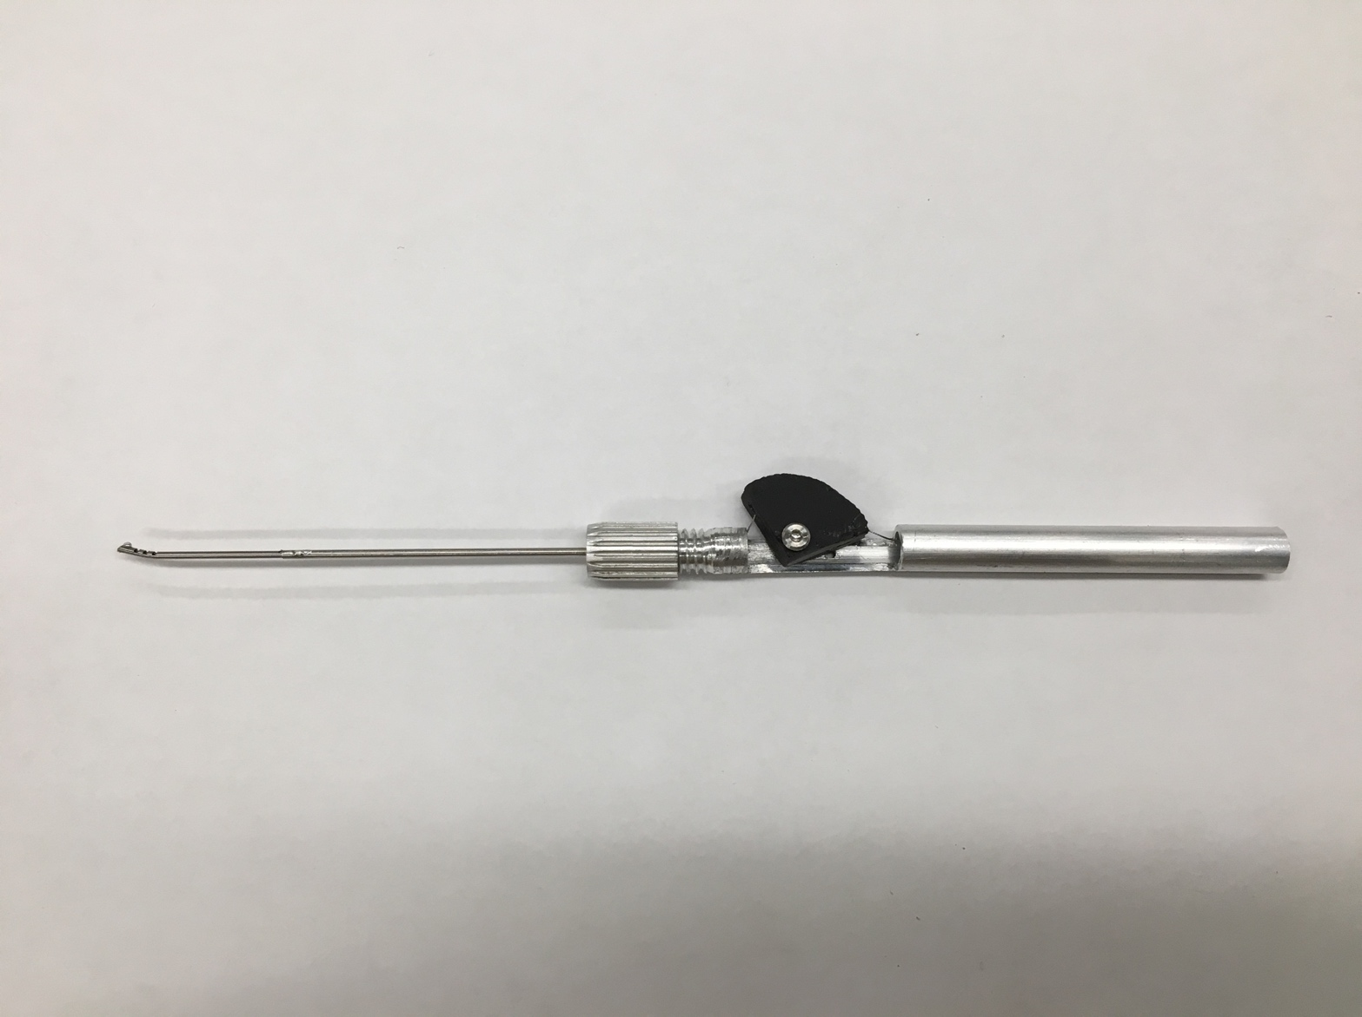**Phase 2: Development and Presentation of a Prototype Instrument:** A prototype (shown below) was manufactured at the lab using Solidworks, 3D printing, a micro-milling machine and assembly of components purchased from McMaster Carr. This instrument has a flexible tip that can bend in one degree of freedom, controlled by the black “thumb piece”. This prototype was presented at the 2nd World Congress of Endoscopic Ear Surgery in Bologna, Italy on April 29, 2017. I also received comments on how to improve upon the tool and how helpful the tool would be by surgeons who attended the conference. As well, by attending the conference, I learned more about endoscopic ear surgery to help my research in the future.

**Phase 3: Refining the Prototype Using Patient Anatomical Data:** Future work includes refining the prototype so that the tip can be bent into curvature whose parameters are appropriate for accessing patient anatomy. The PI has provided several patient CT scans whose anatomy were challenging for TEES and these CT scans have been segmented into 3D models, onto which a CAD of the tool is integrated and the appropriate arc length and radius of curvature of the tool will be determined. Use of the CT scans has SickKids REB approval.

**Phase 4: Validation of the Tool:** 3D printed temporal bone models will be given to TEES surgeons with the final prototype to assess the effectiveness and feel of the tool. The effectiveness will be measured by determining whether or not the tip can reach the intended areas within the anatomy using the endoscope and feel will be ranked using a survey. An REB application has been submitted to conduct this study.